ASSIGNMENT NO 9

Nirbhay Ahir

[Nirbhay.ahir36@gmail.com](mailto:Nirbhay.ahir36@gmail.com)

1. To what does a relative path refer?

Ans: Relative path refers to the location of the directory relative to another directiory.

It contains information to locate file with respect to current working directory.

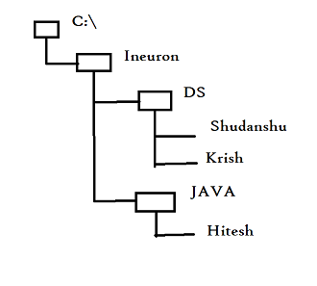for eg:

Absolute Path :

C:\Ineuron\DS\Shudanshu

Relative path:

DS\Shudanshu

2. What does an absolute path start with your operating system?

Ans: I have a windows OS, therefore in Windows based Operating systems absolute path starts with C:

In linux and macOS system it starts with /

3. What do the functions os.getcwd() and os.chdir() do?

Ans: os.getcwd() is used to obtain the location of the current working directory.

Whereas os.chdir() is used to change the current working directory to a specified path. We have to to pass the path inside it.

4. What are the . and .. folders?

Ans: ‘ . ’ represents the current working directory whereas ‘ . . ’ represents the parent directory of the current working directory.

Eg. If I am working with C:\Ineuron\DS\Shudanshu\Python , the ‘ . ‘ represents the path C:\Ineuron\DS\Shudanshu\Python and ‘ . . ‘ will represent the path C:\Ineuron\DS\Shudanshu

5. In C:\bacon\eggs\spam.txt, which part is the dir name, and which part is the base name?

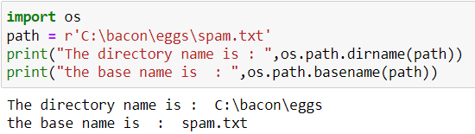Ans:

6. What are the three “mode” arguments that can be passed to the open() function?

Ans: The three mode arguments that can be passed are ‘r’ for read mode , ‘w’ for write mode and ‘a’ for append mode.

7. What happens if an existing file is opened in write mode?

Ans: If an existing file is opened in write mode we can overwrite any existing content present in the file. The existing file is erased and overwritten.

8. How do you tell the difference between read() and readlines()?

Ans: The read() method returns the file's entire contents as a single string value. The readlines() method returns a list of strings, where each string is a line from the file's contents.

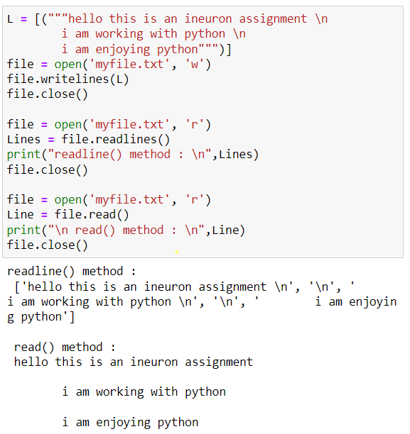

9. What data structure does a shelf value resemble?

Ans: A shelf value resembles a dictionary value; it has keys and values, along with keys() and values() methods that work similarly to the dictionary methods of the same names.